**Example of using Windows ldp.exe to verify the Clearwell ldap configuration.**  
1. Run ldp.exe.  
  
2. Connect to the ldap server.  
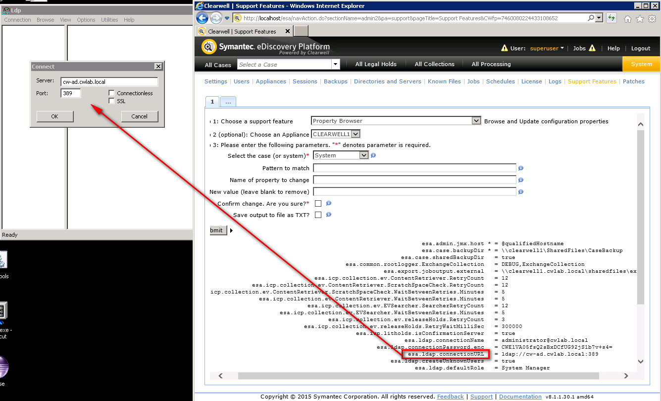

Example of successful connection:  
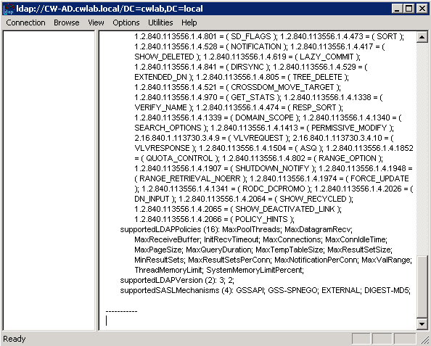  
  
Example of failed connection:  
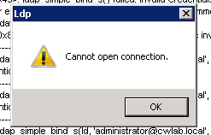  
  
2. Bind to the ldap server.  
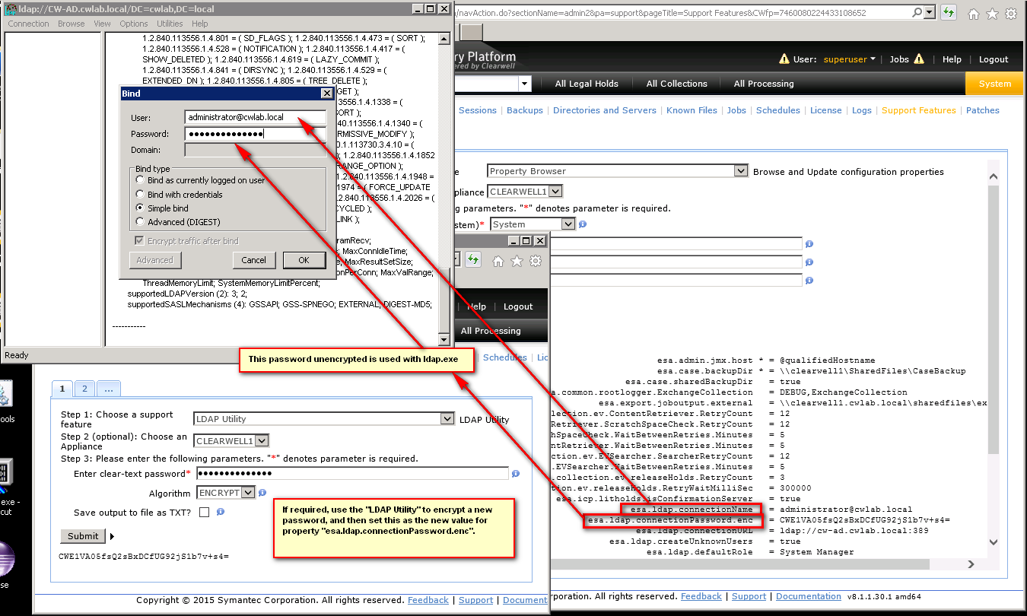

Example of successful bind:  
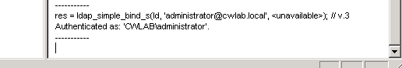  
  
Example of failed bind:  
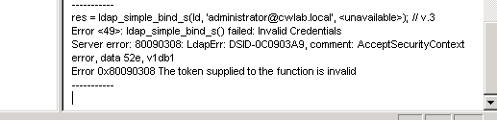  
**Note**: The value “52e” indicates “invalid credentials”, see <https://www-01.ibm.com/support/docview.wss?uid=swg21290631>. Apparently: *“username is valid but password/credential is invalid.”.*  
  
3. To simulate an actual user login, use the “LDAP Configuration Tester” support feature:  
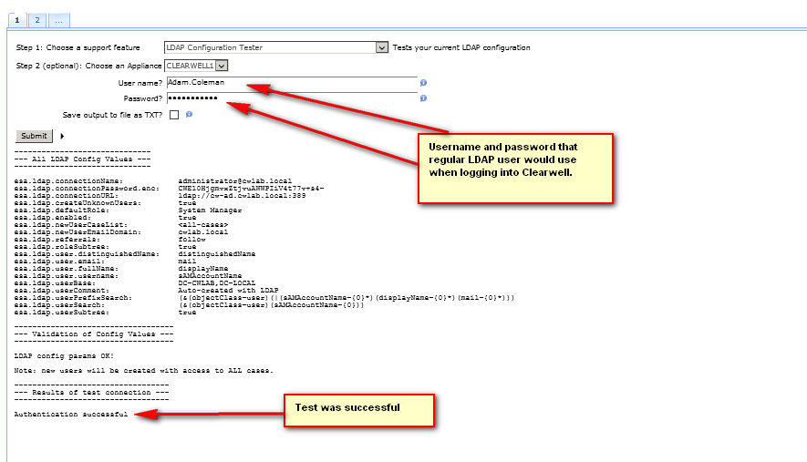  
**Note:** This test will fail if **esa.ldap.createUnknownUsers** is set to **false** and the user does not yet exist under “System > Users”.  
**Note:** Using the “**LDAP Configuration Tester**” support feature when **esa.ldap.createUnknownUsers** is set to **true**, will actually populate an entry in “**System > Users**” for the user being tested! I wasn’t expecting that, for a test. (testing on 811 only).  
  
  
4. Example of using ldp.exe to actually find one of our users in AD:  
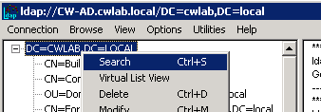   
… and then searching with **(&(objectclass=user)(sAMAccountName=Adam.Coleman))** and adding **sAMAccountName** to the list in **Attributes** we can then see the **sAMAccountName** value:

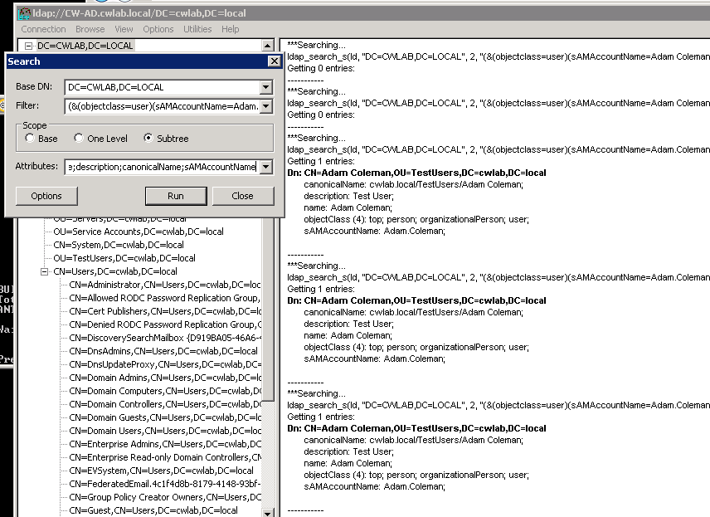  
This indicates that “Adam.Coleman” should be the value used when logging into CW:  
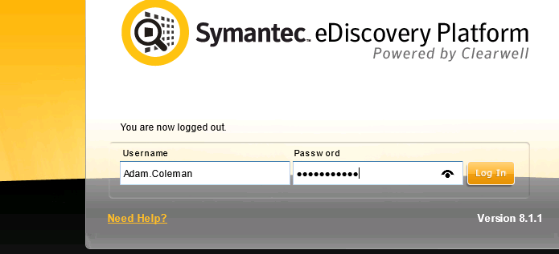  
  
**Note:** If you don’t yet know the exact format of **sAMAccountName**, then first search for the user using a wild-card syntax:  
 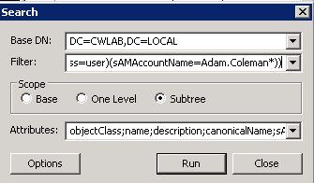  
**NOTE: Remember to remove the “{“ and “}” when testing with a real user name as shown above!**

*JeremyC 16/1/2017***END**